Hemming Jeans Like a Pro

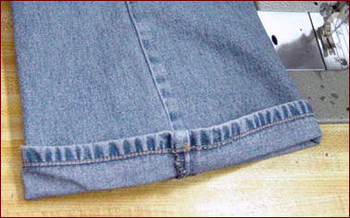
Start by making a cuff, like this one. The idea is to have the wear on the hem stitching show. Then figure
out how many inches you need to take off.

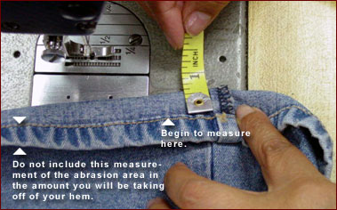
Now for the fun stuff! Divide the amount your taking off in 1/2 and place your tape measure or small ruler on the edge of the hem. Measure the same amount all around the hem, and pin in sections to make sure you will take off the same amount all around.

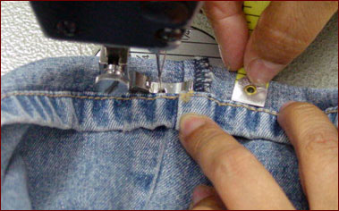
Place the sewing foot on the edge of the hem, like shown above, and slowly stitch the cuff all the way around. Make sure that it measures the same all the way around.

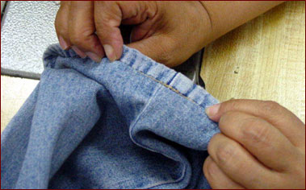
Okay, the hard work is all over. The original worn hem and stitching should be visible. If it's not, then it's either time to start over, or it's time to let the pros handle it.

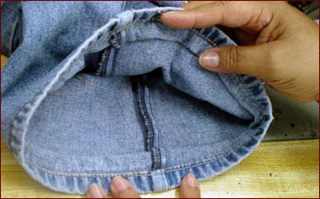
Push the extra fabric inside upwards if it is a small amount. If it's a huge wad of fabric then grab your scissors and cut off some of the extra fabric, leaving about 3/4" to allow for fraying in the wash.

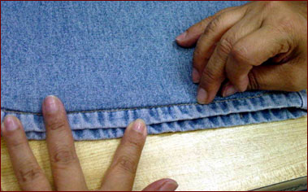
Turn the leg right side out and lay it flat. With your fingertips, press the seam you just created flat.

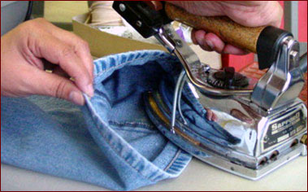
On the inside of the leg, use your iron to press the extra fabric upwards.

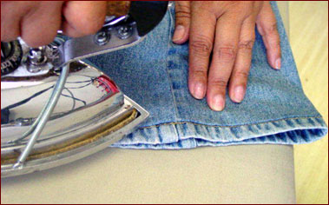
Then press the outside of the leg until it is nice and flat.

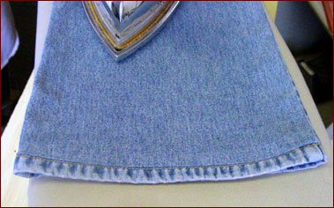
There you have it! Can you tell the difference?

